QMFM
Fiscal Impulse and Govt demand (trend/structural) recalibration and tuning
- Fiscal Impulse---final demand(G&S) and priv. investment---increased respective coefficients
IRFs
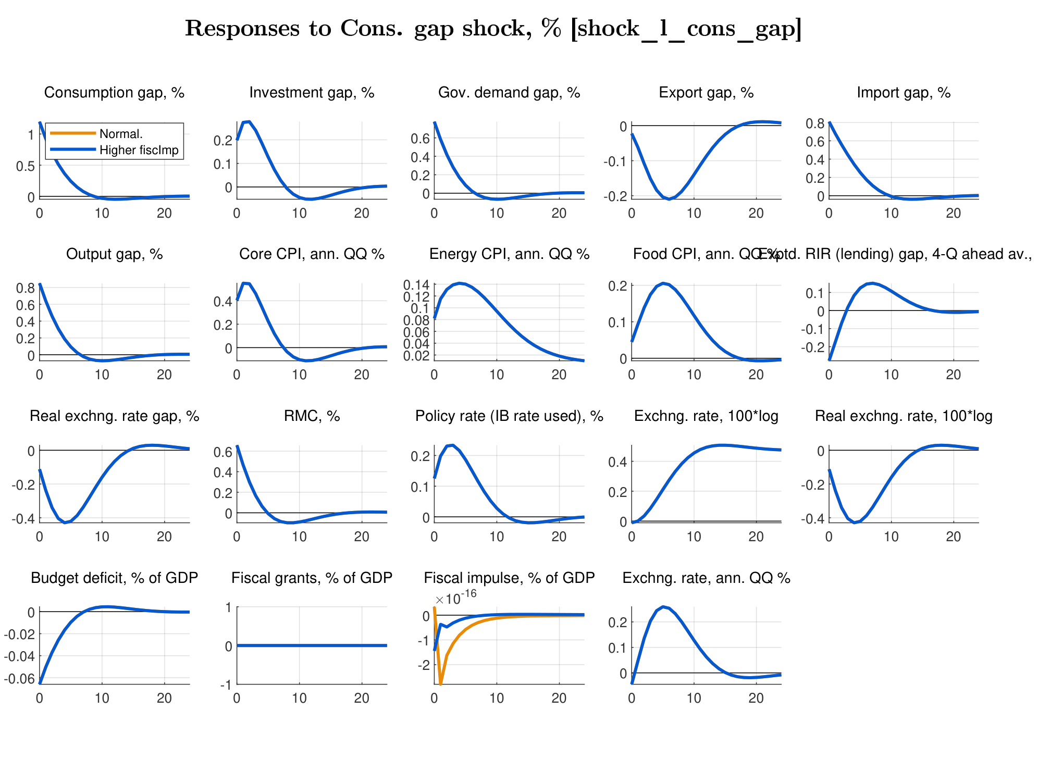
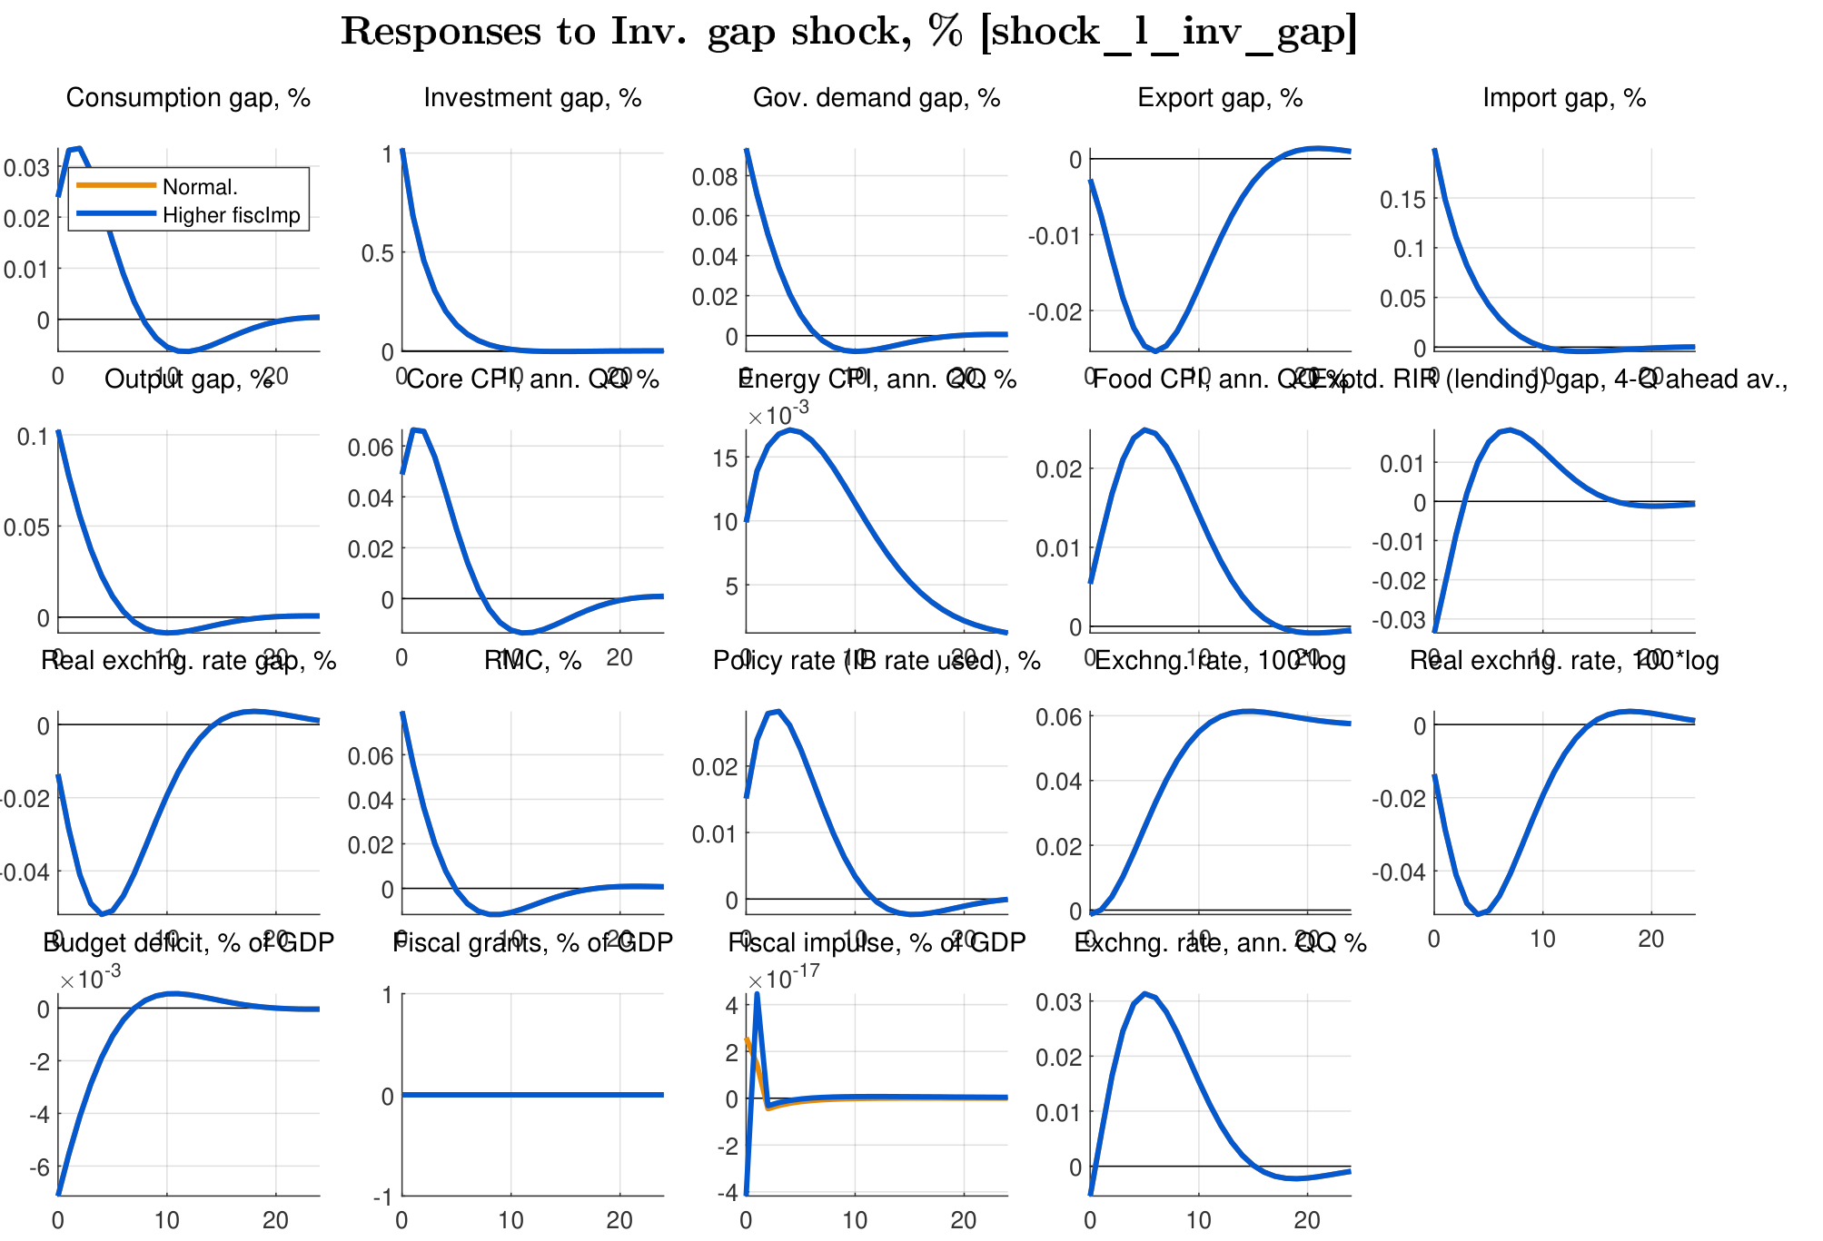

Apparently, the structural trend was historically bent in around COVID according to obs. data ---bend it deeper?
Filtration report (Init. condition)
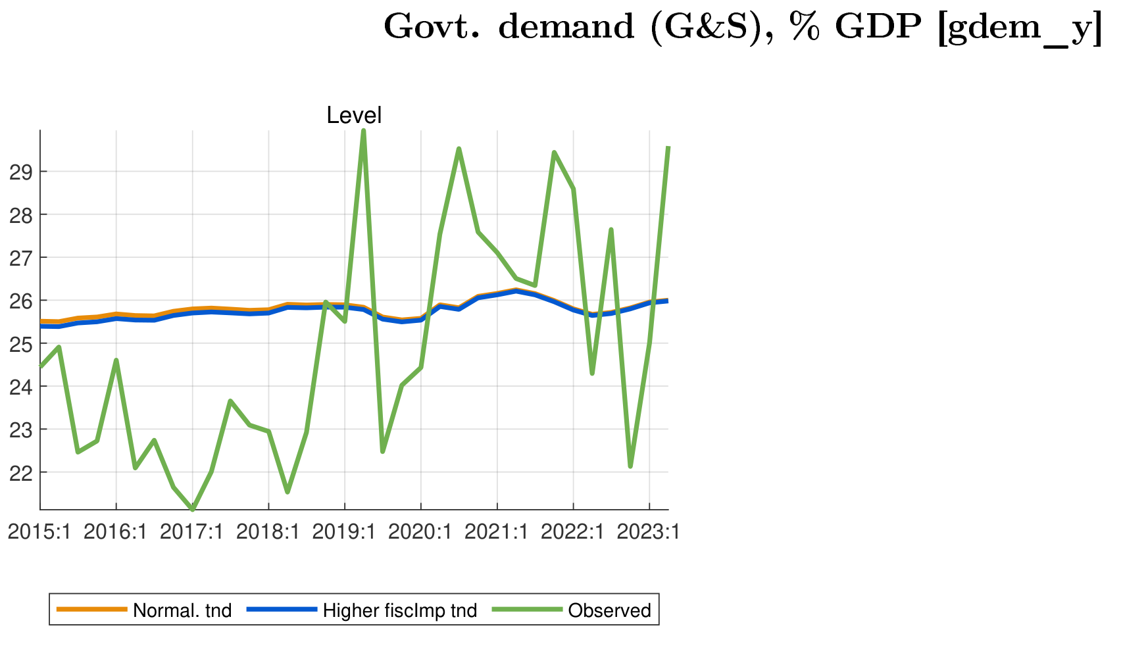
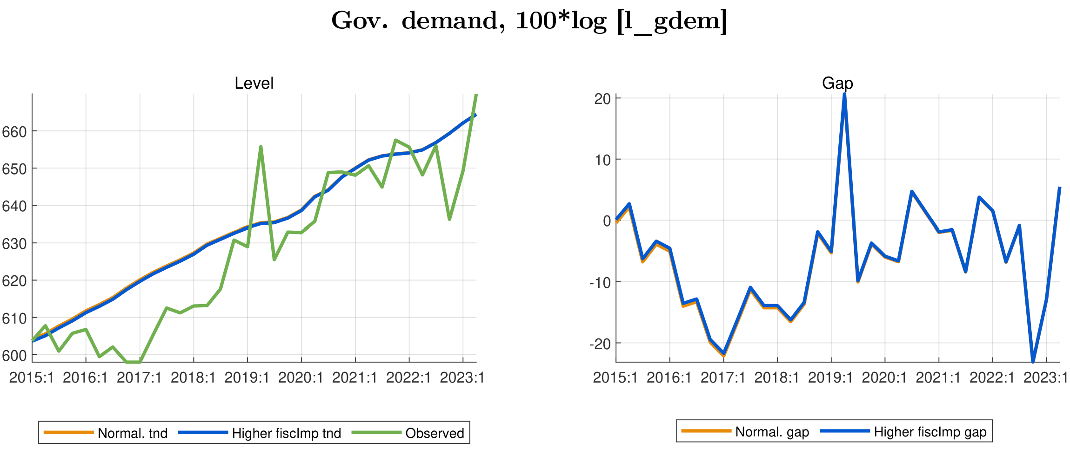

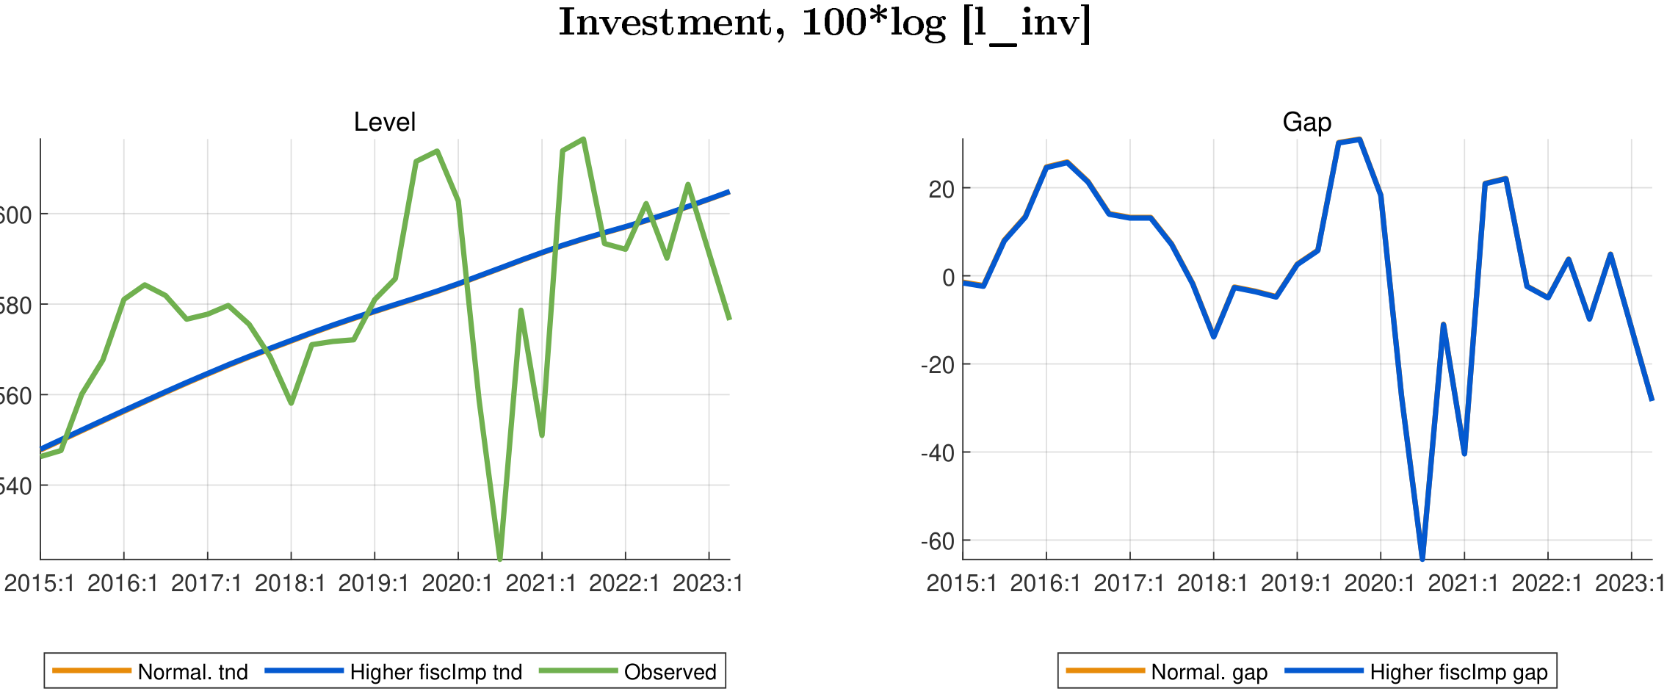
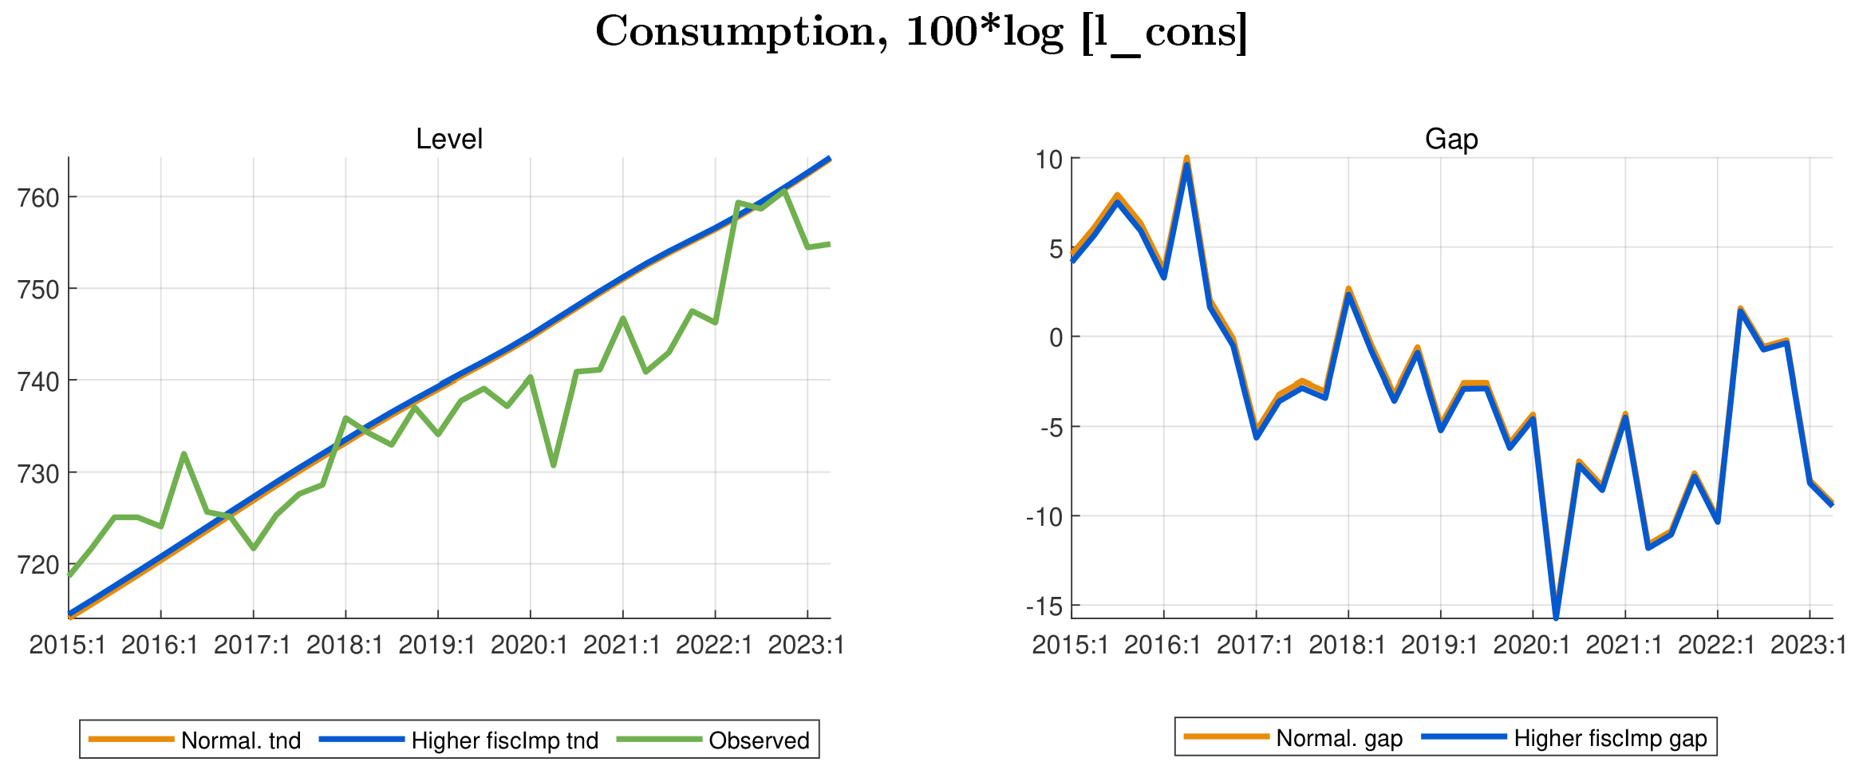

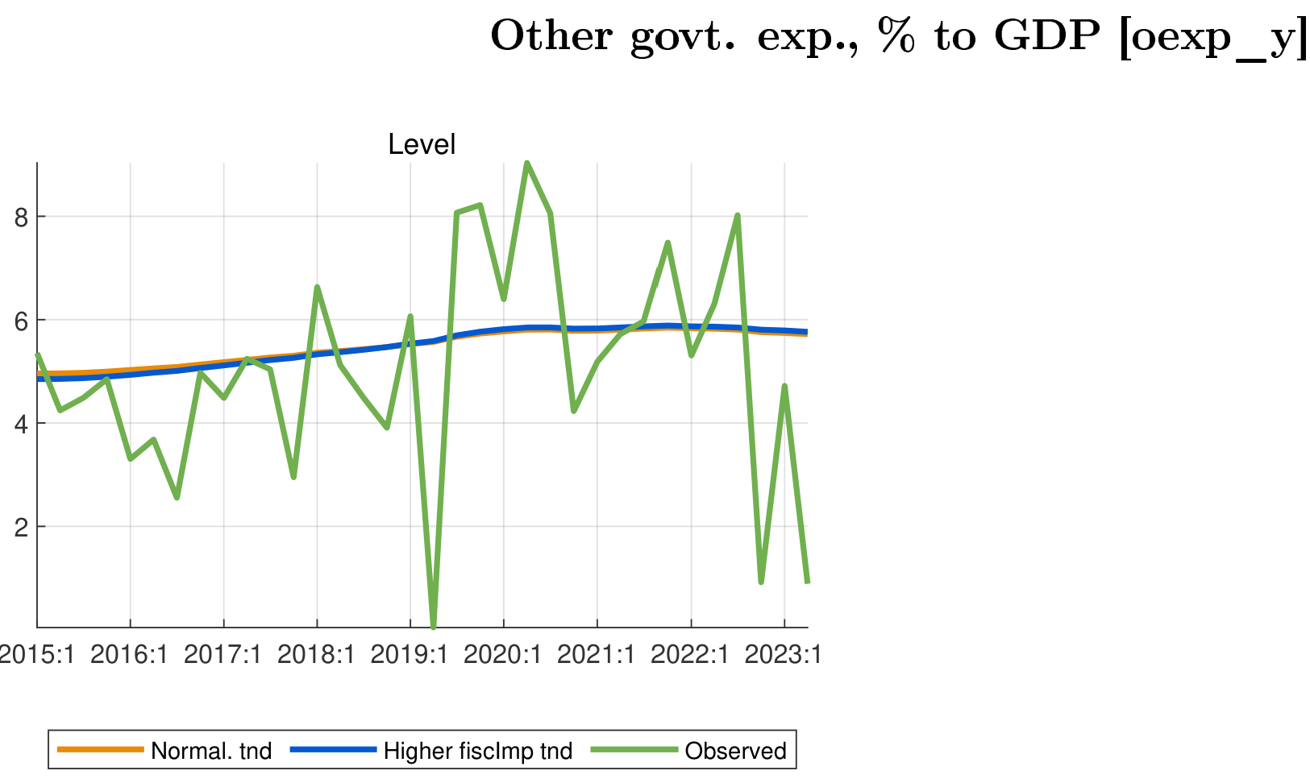

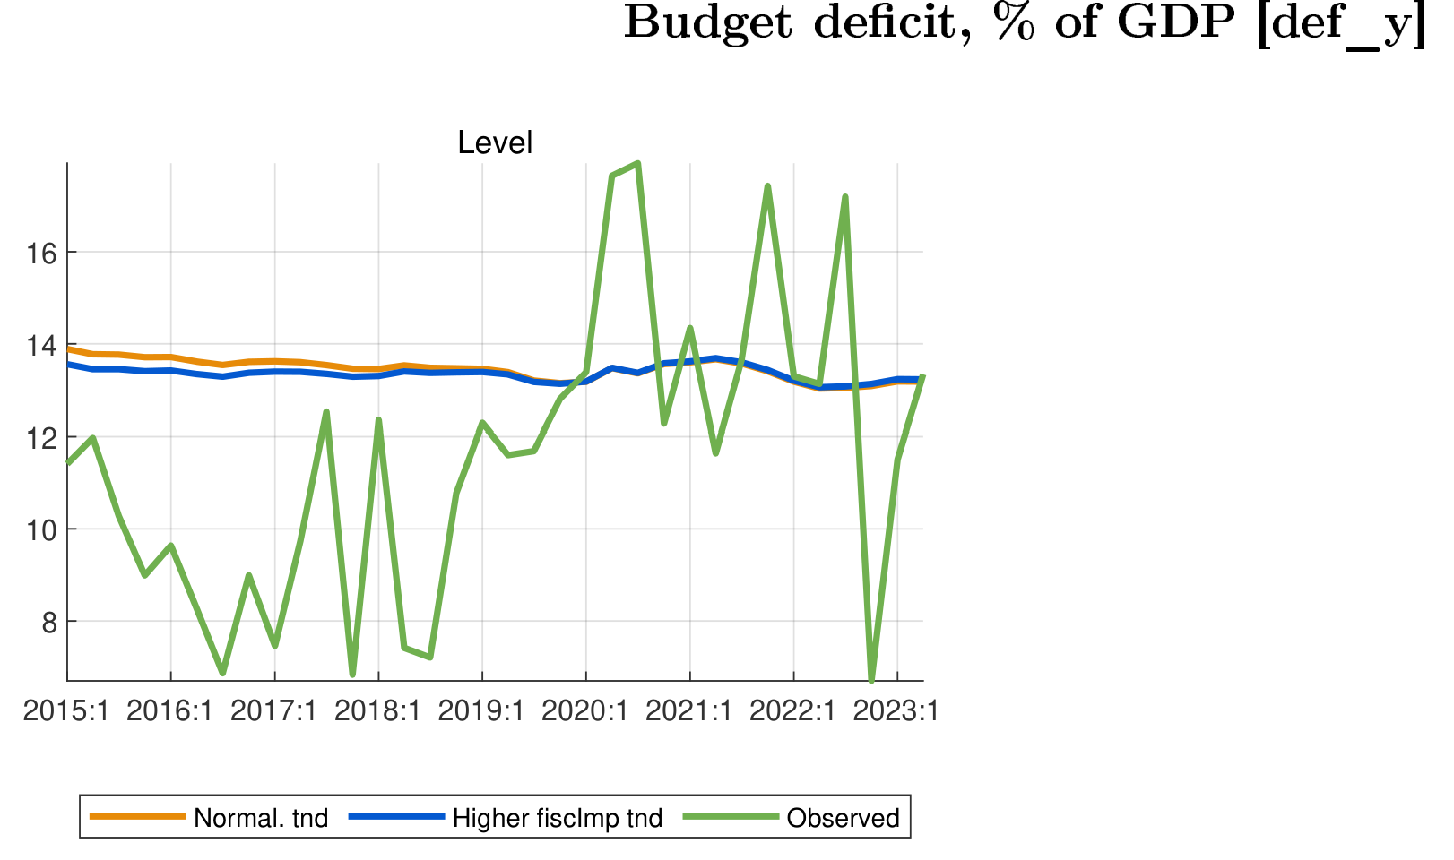

Govt demand trend as effect of increased fisc. impulse---hist trend averaged to 25%
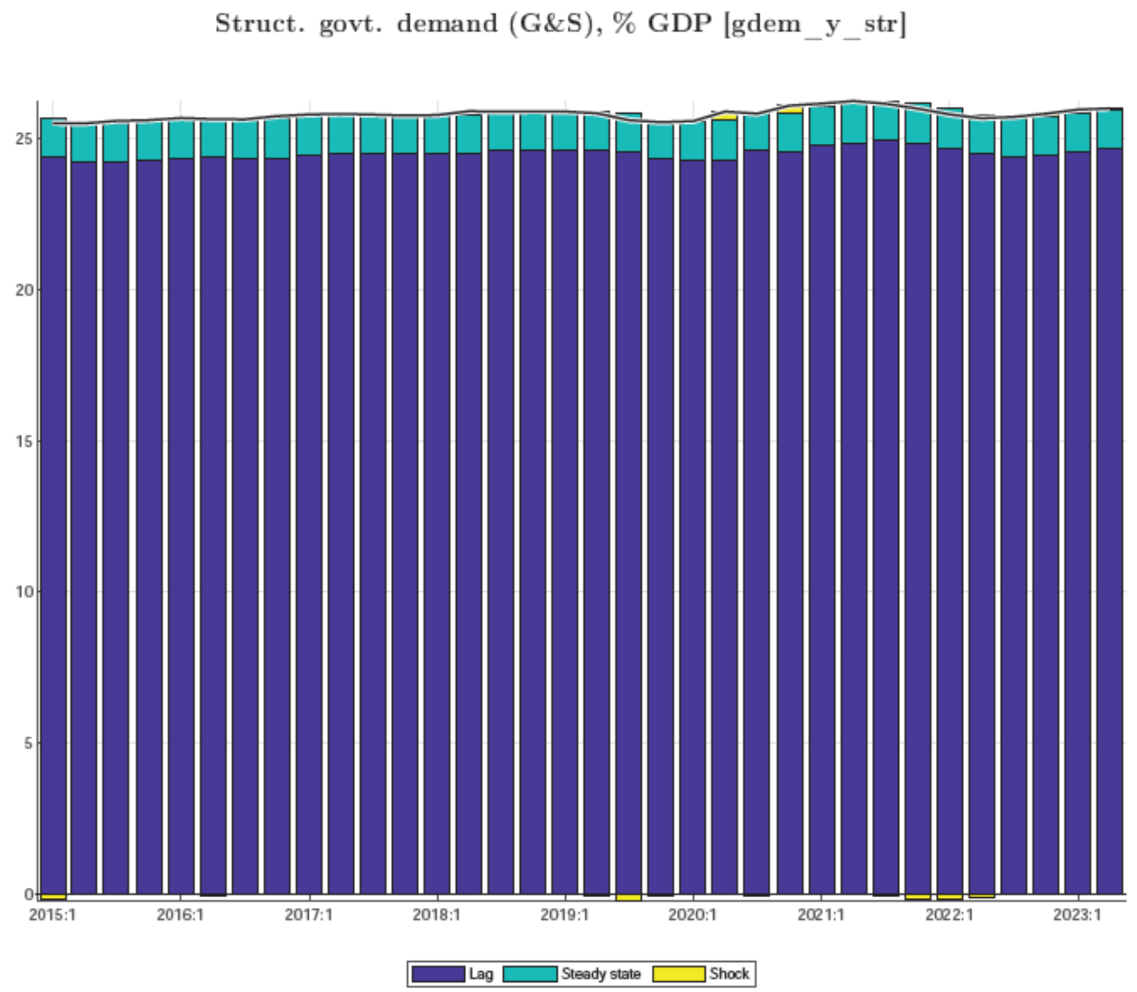
The structural Govt demand trend before tuning and calibration

- Govt demand (trend/structural) tuning (2017-2023)--- incl. fiscal impulse calibration
Filtration report (Init. Condition)
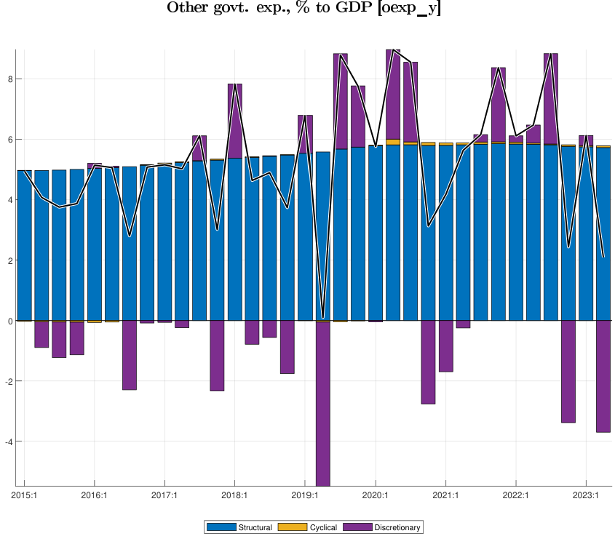
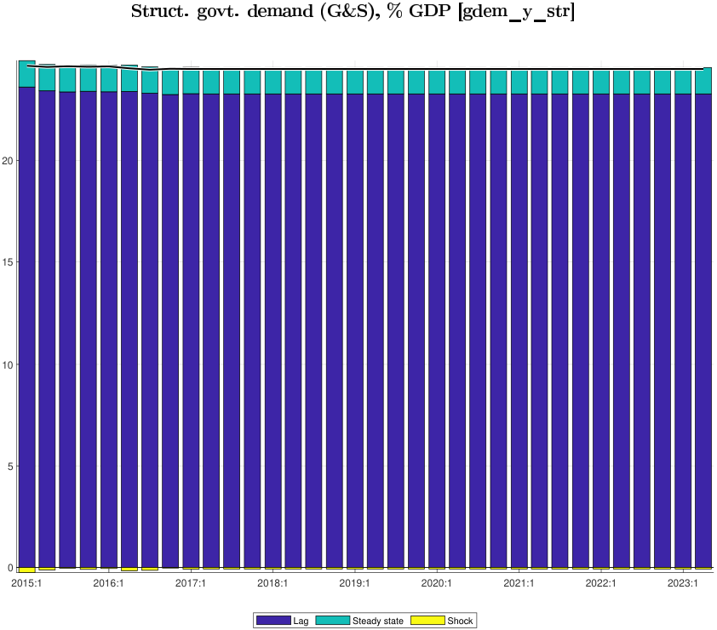
A sizable fiscal impulse post 2019
-less negative (2017-2020)
-more positive post 2020 ( >4%)
-disappearance of change in str. def post 2017
Seems the tuned trend can be enough to lift up fiscal impulse
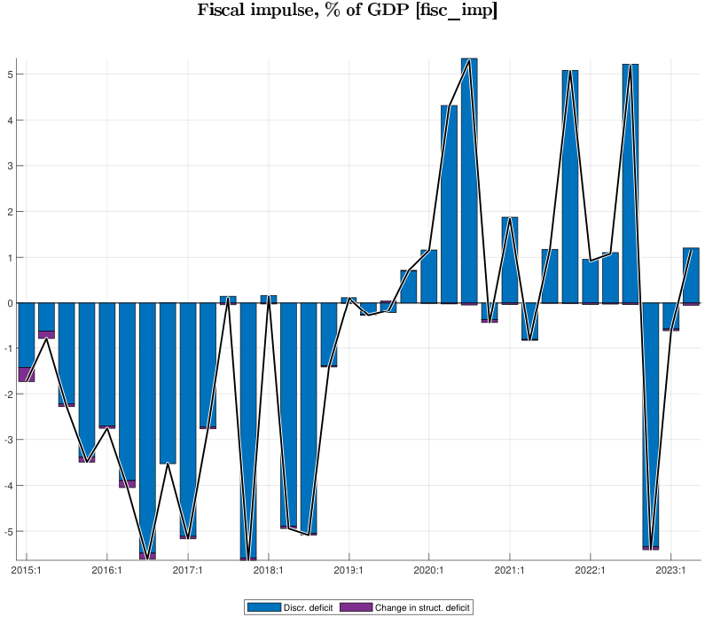
tunes deem to have lowered trend even in COVID.
-higher other-expenditure (structural? & discretional)
-higher deficit (discretional)
